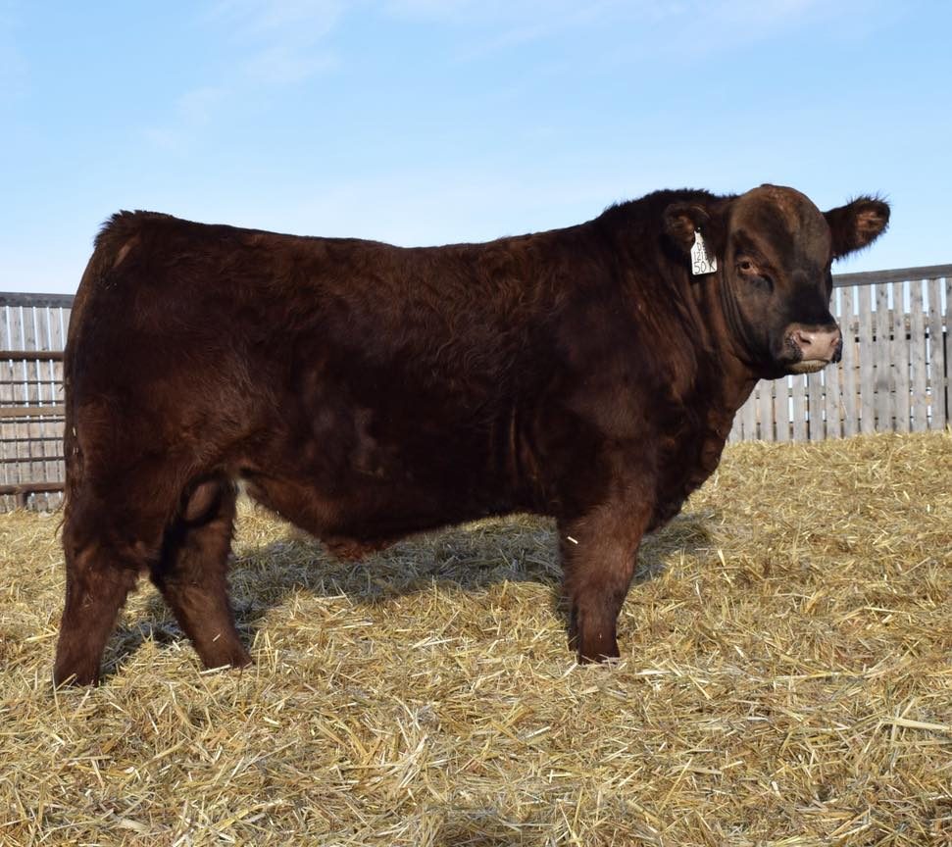
J Bar Stenberg Ranch

Thanks to David Prokuda & ProChar for producing World Class Charolais cattle. Your keen eye and commitment to continuously enhance your herds genetics is ever apparent in your sale offerings. We feel fortunate and thrilled in our purchase of Lot 4 and can hardly wait to introduce him to his Montana ladies.
Jerome & Jarrod
J Bar Stenberg Ranch

